Continuous Random Variables: Review

Questions 1 – 7 refer to the following study: A recent study of mothers of junior high school children in Santa Clara County reported that 76% of the mothers are employed in paid positions. Of those mothers who are employed, 64% work full-time (over 35 hours per week), and 36% work part-time. However, out of all of the mothers in the population, 49% work full-time. The population under study is made up of mothers of junior high school children in Santa Clara County.
Let E = employed Let F = full-time employment

Exercise 1:
- Find the percent of all mothers in the population that NOT employed.
- Find the percent of mothers in the population that are employed part-time.
Exercise 2:
The type of employment is considered to be what type of data?
Exercise 3:
In symbols, what does the 36% represent?
Exercise 4
Find the probability that a randomly selected person from the population will be employed OR work full-time.

Exercise 5

Based upon the above information, are being employed AND working part-time:
- mutually exclusive events? Why or why not?
- independent events? Why or why not?

Questions 6 - 7 refer to the following: We randomly pick 10 mothers from the above population. We are interested in the number of the mothers that are employed. Let X = number of mothers that are employed.

Exercise 6
State the distribution for X.
Exercise 7
Find the probability that at least 6 are employed.
Exercise 8
We expect the Statistics Discussion Board to have, on average, 14 questions posted to it per week. We are interested in the number of questions posted to it per day.
- Define X.
- What are the values that the random variable may take on?
- State the distribution for X.
- Find the probability that from 10 to 14 (inclusive) questions are posted to the Listserv on a randomly picked day.

Exercise 9
A person invests $1000 in stock of a company that hopes to go public in 1 year.
- The probability that the person will lose all his money after 1 year (i.e. his stock will be worthless) is 35%.
- The probability that the person’s stock will still have a value of $1000 after 1 year (i.e. no profit and no loss) is 60%.
- The probability that the person’s stock will increase in value by $10,000 after 1 year (i.e. will be worth $11,000) is 5%.
Find the expected PROFIT after 1 year.
Exercise 10
10. Rachel’s piano cost $3000. The average cost for a piano is $4000 with a standard deviation of $2500.Becca’s guitar cost $550. The average cost for a guitar is $500 with a standard deviation of $200. Matt’s drums cost $600. The average cost for drums is $700 with a standard deviation of $100. Whose cost was lowest when compared to his or her own instrument? Justify your answer.
Exercise 11
For the following data, which of the measures of central tendency would be the LEAST useful: mean, median, mode? Explain why. Which would be the MOST useful? Explain why.
Data: 4, 6, 6, 12, 18, 18, 18, 200
Exercise 12
For each statement below, explain why each is either true or false.
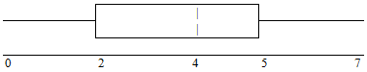
- 25% of the data are at most 5.
- There is the same amount of data from 4 – 5 as there is from 5 – 7.
- There are no data values of 3.
- 50% of the data are 4.
Questions 13 – 14 refer to the following: 64 faculty members were asked the number of cars they owned (including spouse and children’s cars). The results are given in the following graph:
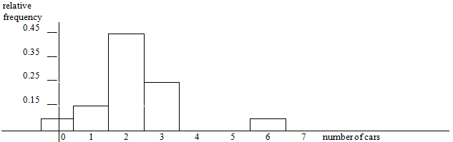
Exercise 13
Find the approximate number of responses that were “3.”
Exercise 14

Find the first, second and third quartiles. Use them to construct a box plot of the data.
Questions 15 – 16 refer to the following study done of the Girls soccer team “Snow Leopards”:
Hair Style | Hair Color
Hair Style | Blond | Brown | Black
Ponytail | 3 | 2 | 5
Plain | 2 | 2 | 1

Suppose that one girl from the Snow Leopards is randomly selected.
Exercise 15
Find the probability that the girl has black hair GIVEN that she wears a ponytail.
Exercise 16
Find the probability that the girl wears her hair plain OR has brown hair.
Exercise 17
Find the probability that the girl has blond hair AND that she wears her hair plain.

